**Bibliometric analysis by co-occurrence (author keywords)**

Bibliometric analysis used as scientific metrics to give an indicator that reflect the importance of the research and help to highlight the research gap of this review. Bibliometric maps was analysed by 155 articles from Scopus databased. The number of articles used was extracted from Scopus after limitations process. Five different types of limitations used as follow; keywords, last 5 years, type of documents (review and journal papers), English language.

The keywords used were ((“concrete”) AND (“durability”) AND (“glass”)) respectively. The number of authors keywords with 3 times occurrence, total links strength and clusters were 8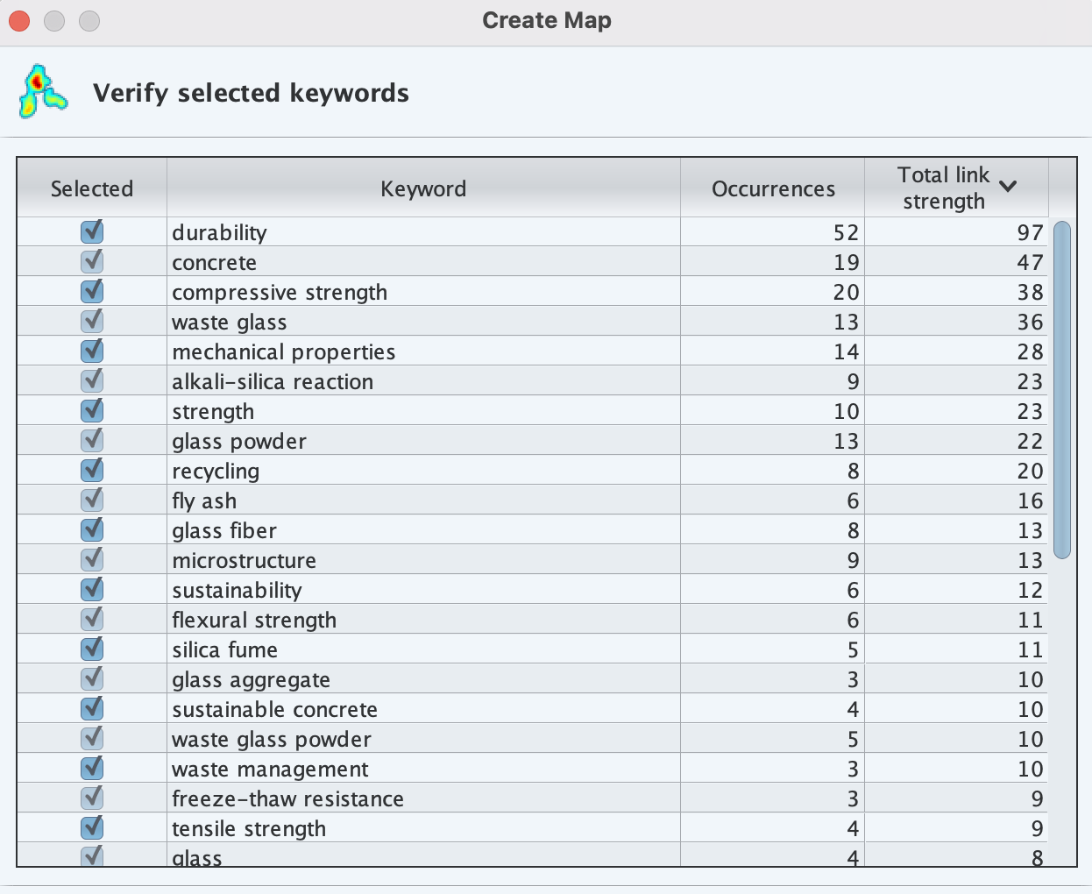7, 284 and 7 respectively. The authors keywords occurred more than 5 times were 22 as shown in Table 1.

The keywords used are (( concrete )) AND (( “selfhealing” OR “selfhealing” )) AND (“carbonation” OR "CO2" OR “carbon dioxide”) respectively. The number of authors keywords with 3 times occurrence, total links strength and clusters were 50, 288 and 8 respectively. The authors keywords occurred more than 5 times were 22 as shown in Table 1. It can be seen self-healing occurred more than 100 times with high level of total strength in the selected articles. However, carbonation and corrosion protections occurred 6 times only with total strength 9 and 5 respectively. This finding can give an indicator the study of self-healing from previous researcher did not focused more about corrosion protections as well as carbonation of concrete.



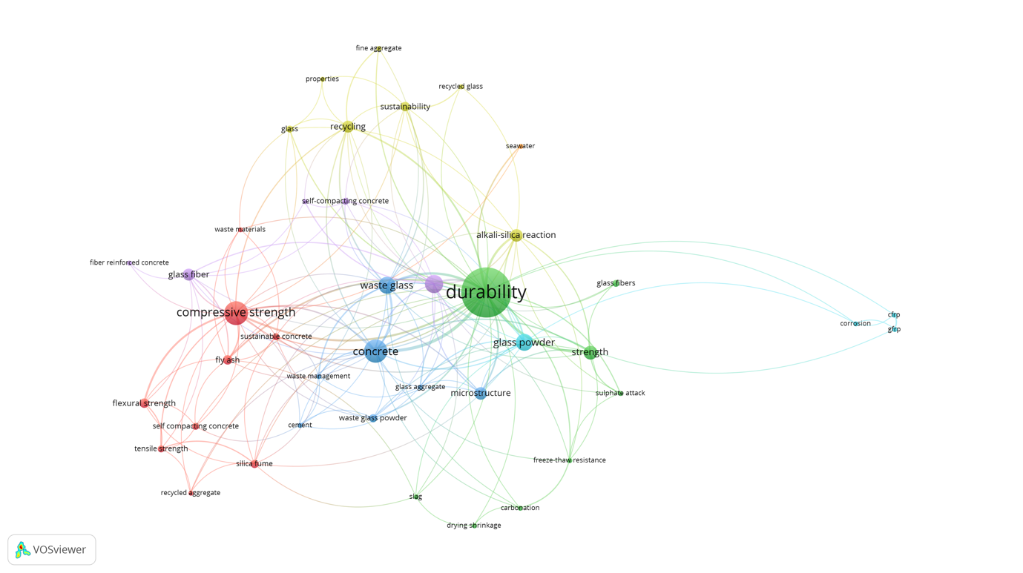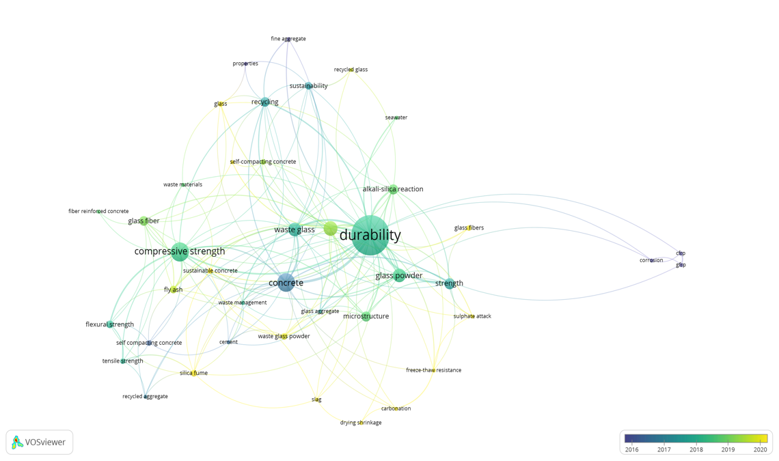

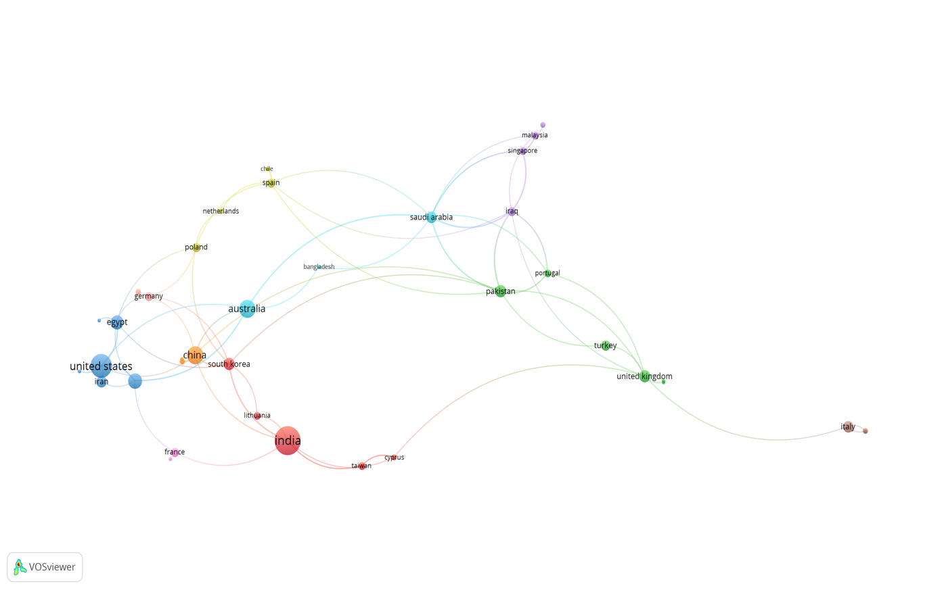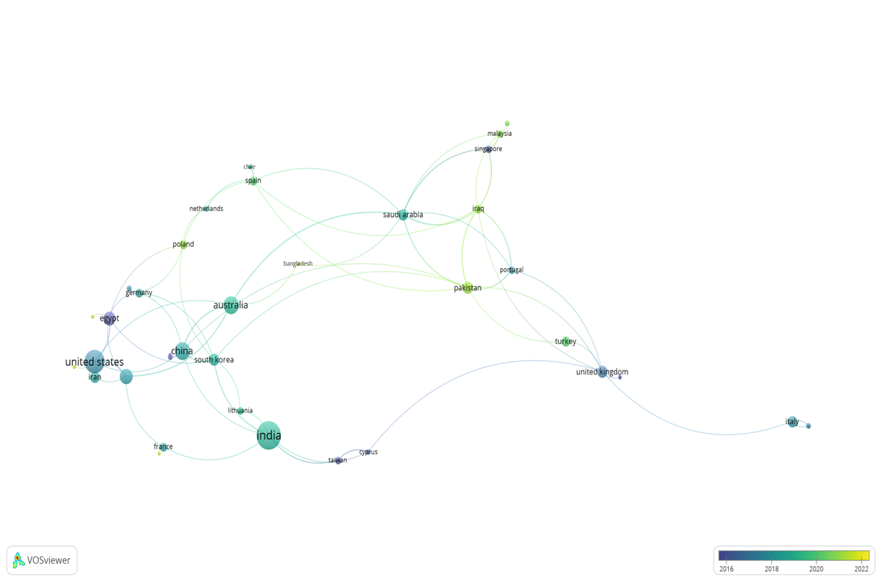

**Bibliometric analysis by co-occurrence (author keywords)**

Bibliometric analysis used as scientific metrics to give a strong indicator and highlight the research gap of this review. Bibliometric maps was analysed by 282 articles from Scopus databased using 5 different categories of limitations as follow; keywords, last 5 years, type of documents (review and journal papers), English language. The keywords and their synonyms used are (( concrete )) AND (( “selfhealing” OR “selfhealing” )) AND (“carbonation” OR "CO2" OR “carbon dioxide”) respectively. The number of authors keywords with 3 times occurrence, total links strength and clusters were 50, 288 and 8 respectively. The authors keywords occurred more than 5 times were 22 as shown in Table 1. It can be seen self-healing occurred more than 100 times with high level of total strength in the selected articles. However, carbonation and corrosion protections occurred 6 times only with total strength 9 and 5 respectively. This finding can give an indicator the study of self-healing from previous researcher did not focused more about corrosion protections as well as carbonation of concrete.

Table 1. The authors keywords occurred more than 5 times in VOSviewer software.

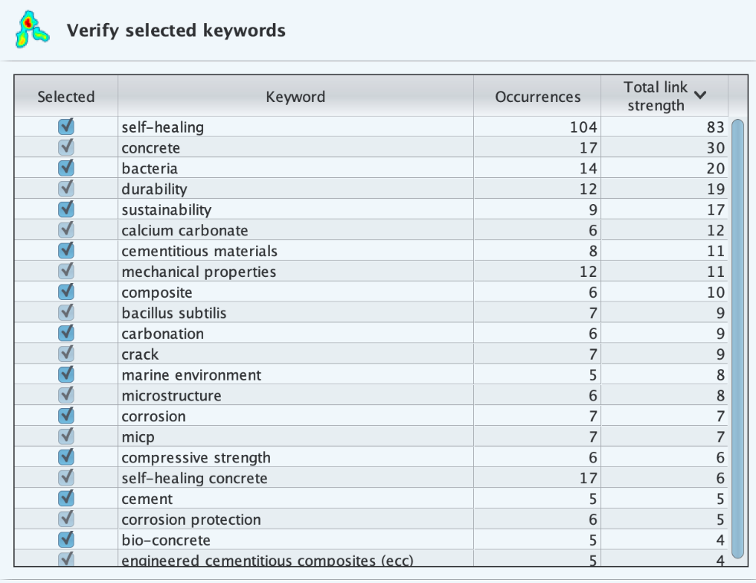

The network visualization in Figure 1(a) represents the items by their label and circle. The size of the circles of the mentioned top 5 keywords are determined by the weight of the item. The large circle represents the higher weight of the items. The frequency of the keywords which occurred more than 5 times and the wight of the items were indicated that most of the researchers worldwide are studied the new applications of self-healing in bio-concrete. This finding can give a clear view of the future applications corrosion protections of concrete reinforcement using self-healing approach which can be consider as the mostly applied at the last 5 years as presents in Overly visualization map Figure 1(b).

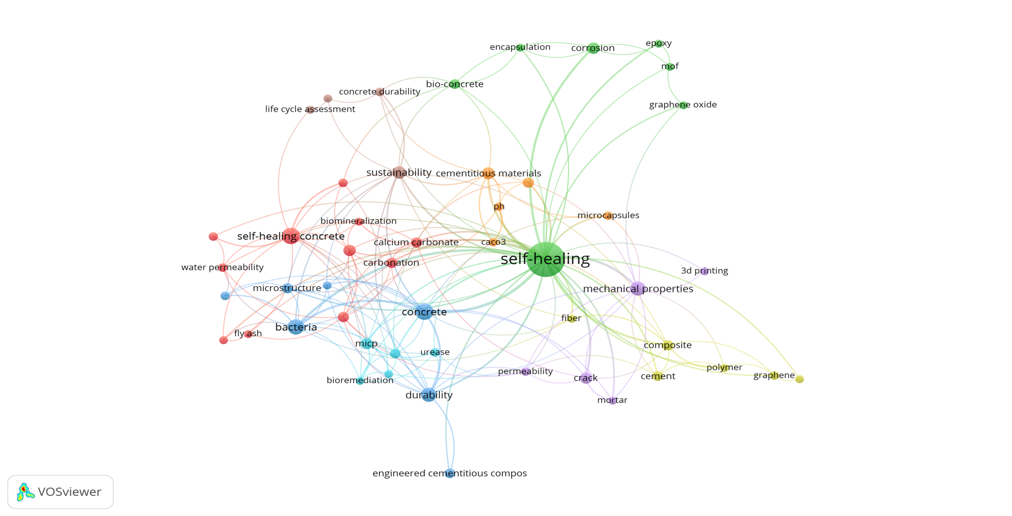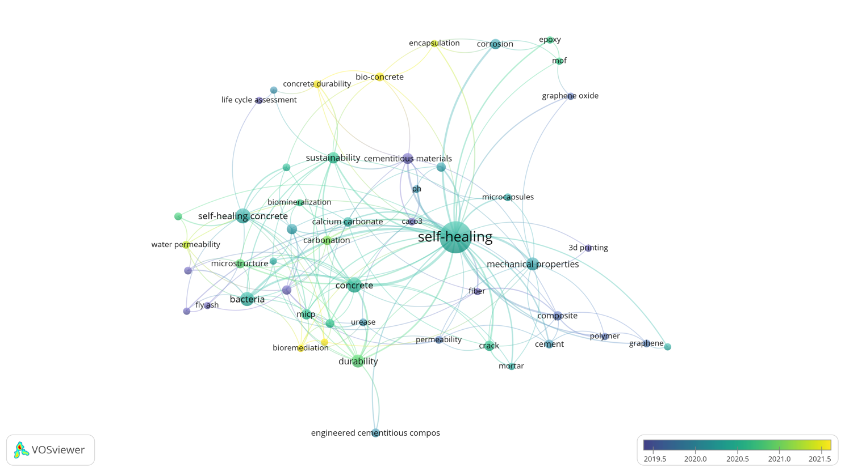

**Figure 1.** Bibliometric analysis of the keywords in publications of concrete self-healing and carbonation. (A) Network Visualizations to present theoccurrence of keywords used by authors and the number of clusters, (B) Overlay Visualizationsoccurrence of keywords used by authors colored based on year color.

**Bibliographic coupling** **analysis (countries)**

The bibliographic coupling analysis of the countries is presenting the total number of the countries published in this research area. Only 51 countries have been contributed by one research and more on this analysis. The countries that participated by the publications in this area are presented in Figure 2. The top five countries published articles in this area are China, United States, United Kingdom Australia and India by 88, 32, 21, 18 and 17 respectively. Unfortunately, most of these countries such as United States, United Kingdom, Germany and Belgium are raised this issue before and after 2019 as present in overly visualization map Figure 3. However, the countries such as China Australia, India, Canada and Malaysia have been focused on this area of research on 2020 and above. In addition, some countries started to conducted some researches in this regard starting from 2021 up to now such as Ireland, Taiwan, Cyprus and Bangladesh. According to the previous discussion it can be expected that, this topic will have many applications in the coming years as well as many publications worldwide.

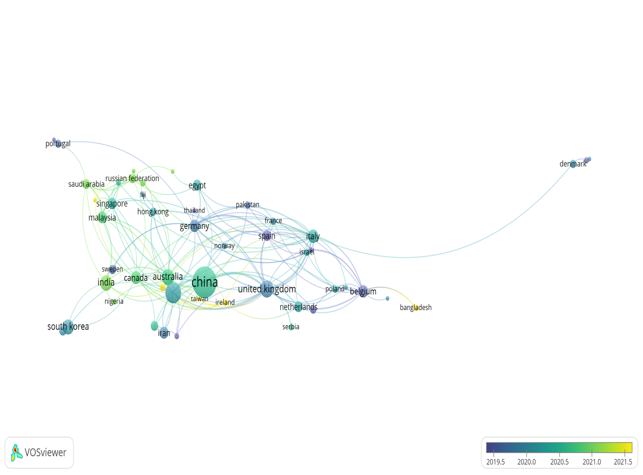

**Figure 2.** Bibliometric analysis of co-authorship (countries)Overlay Visualizationsoccurrence of countries published which coloured according of publication years of concrete self-healing and carbonation.

